**The Mirfield Liturgical Institute**

Post-Graduate Diploma and MA in Worship & Liturgical Studies (*University of Durham, Common Awards*).

Do you want to improve your skills and understanding of worship and liturgy? If so, this exciting new programme leading to a post-graduate qualification which is tailored to practise and theology, answering the questions worship poses today, is for you!”   

Drawing on an international and ecumenical team of specialists, we will enable you to understand Christian liturgy and provide you with the skills to develop it in your church community.

This will be wholly distance learning, mostly on-line, but with an optional summer-school based in Mirfield, home of the Mirfield Liturgical Institute, an integral part of The College of the Resurrection. We have a long tradition of teaching liturgy dating back to the 1890s; we have the largest liturgical library in England and many other resources for teaching liturgy and worship including striking liturgical spaces.

For further information, please contact:

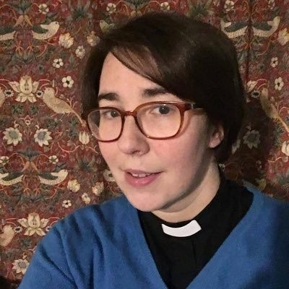  
The Revd Dr Jo Kershaw (Course Director)  
College of The Resurrection  
Stocks Bank Road  
Mirfield  
WF14 0BW

Tel: 01904

Email: [jkershaw@mirfield.org.uk](mailto:jkershaw@mirfield.org.uk)

[www.college.mirfield.org.uk](http://www.college.mirfield.org.uk)

